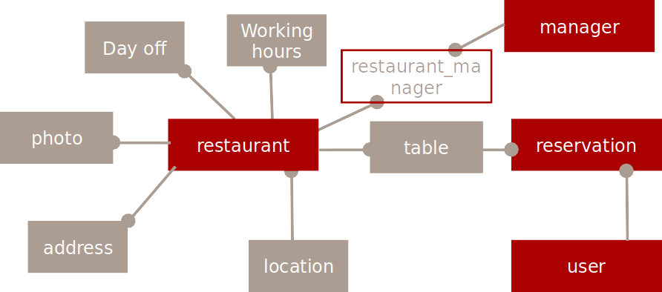

manager
manager_id INT UN PK AI
username VARCHAR 64 UQ
password_hash VARCHAR 128
created_at TIMESTAMP CT
is_active TINYINT 1 UN
location
location_id INT UN PK AI
location_name VARCHAR 64 UQ
restaurant
restaurant_id INT UN PK AI
name VARCHAR 128 UQ
description TEXT
location_id INT UN FK
restaurant_manager
restaurant_manager_id INT UN PK AI
restaurant_id INT UN FK
manager_id INT UN FK
address
address_id INT UN PK AI
street_and_numberVARCHAR 255
city VARCHAR 64
restaurant_id INT UN PK
photo
photo_id INT UN PK AI
name VARCHAR 255
file_path TEXT UQ
restaurant_id INT UN FK
day_off
day_off_id INT UN PK AI
day_off_date DATE
reason TEXT
restaurant_id INT UN FK

working_hours
working_hours_id INT UN PK AI
day VARCHAR 64
opening_hours TIME
closing_hours TIME
restaurant_id INT UN FK
table
table_id INT UN PK AI
table_name VARCHAR 64 UQ
table_capacity INT UN
table_max_reservation_duration DECIMAL UN 10,2
restaurant_id INT UN FK
reservation
reservation_id INT UN PK AI
first_name VARCHAR 64
last_name VARCHAR 64
phone_nubmer VARCHAR 24
email VARCHAR 64
reservation_date DATETIME
reservation_duration DECIMAL UN 10,2
status ENUM(pending, confirmed)
table_id INT UN FK

